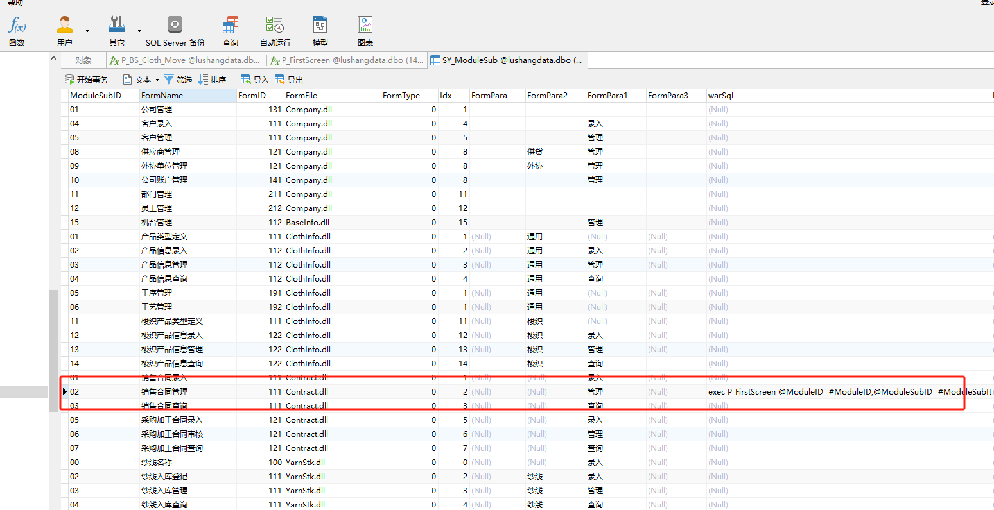ALTER procedure p_select_firstPage_button_right
@userId varchar(50)='',
@type int=0
AS
-- SELECT A.*
-- FROM xs_firstPage_buttons A
-- where A.id in (select button_id from xs_firstpage_button_right B
-- where B.user_id= @userId
-- or B.role_id in (select roleId from sy_user_role x where x.userId=@userid)
-- )
-- and A.stop_flag=0

select top 20 B.*, '' as to_url,B.formName as button_caption,
rtrim(B.moduleid)+rtrim(B.ModulesubID) as id
from sy_purview A
inner join SY_ModuleSub B ON B.moduleid=A.moduleId and B.ModulesubID=A.moduleSubid
where A.userId=@userId
and isnull(B.warSql,'')<>''
union
select top 20 B.*, '' as to_url,B.formName as button_caption,
rtrim(B.moduleid)+rtrim(B.ModulesubID) as id
from sy_role_right A
inner join SY_ModuleSub B ON B.moduleid=A.moduleId and B.ModulesubID=A.moduleSubid
where A.roleId in ( select roleId from sy_user_role x where x.UserId=@userid)
and isnull(B.warSql,'')<>''

ALTER PROCEDURE [dbo].[P_FirstScreen]
@ModuleID varchar(20),
@ModuleSubID varchar(20),
@userId varchar(20)='',
@warName varchar(20)=''
AS
begin

-- exec P_FirstScreen @ModuleID=#ModuleID,@ModuleSubID=#ModuleSubID,@userid=#userid
DECLARE @FormName VARCHAR(60)

set @FormName=ISNULL((select FormName from SY_ModuleSub A inner join SY_Purview B on A.ModuleID=B.ModuleID and A.ModuleSubID=B.ModuleSubID
where UserID=@userid and A.ModuleID=@ModuleID and A.ModuleSubID=@ModuleSubID ), '')

if @FormName='' set @FormName=ISNULL((select FormName from SY_ModuleSub A inner join sy_role_right B on A.ModuleID=B.ModuleID and A.ModuleSubID=B.ModuleSubID
where B.roleId in ( select roleId from sy_user_role x where x.UserId=@userid) and A.ModuleID=@ModuleID and A.ModuleSubID=@ModuleSubID ), '')

--param2 改信息会传递到dll 参数5
if @FormName= '销售合同管理'
begin
select warName=@FormName,param1=(select COUNT(A.CONMID) from Bs_Contract_Main A where Status=1),param2='合同审核'
end
else
if @FormName= '报价管理'
begin
select warName=@FormName,param1=(select COUNT(A.MVCMId) from MV_Cloth_Main A where Status=1),param2='78'
end
else
if @FormName= '采购加工单管理'
begin
select warName=@FormName,param1=(select COUNT(A.PurMId) from Pur_ClothPlan_Main A where Status=1),param2='78'
end
else
if @FormName= '打色单审核'
begin
select warName=@FormName,param1=(select COUNT(A.MainId) from Trade_Plan_Main A where Status=1 and OrdType='打色单'),param2='78'
end
else
if @FormName= '订单审核'
begin
select warName=@FormName,param1=(select COUNT(A.MainId) from Trade_Plan_Main A where Status=1 and OrdType='大货单'),param2='78'
end
else
begin
select warName='待定',x=0,param2=0
end

end

